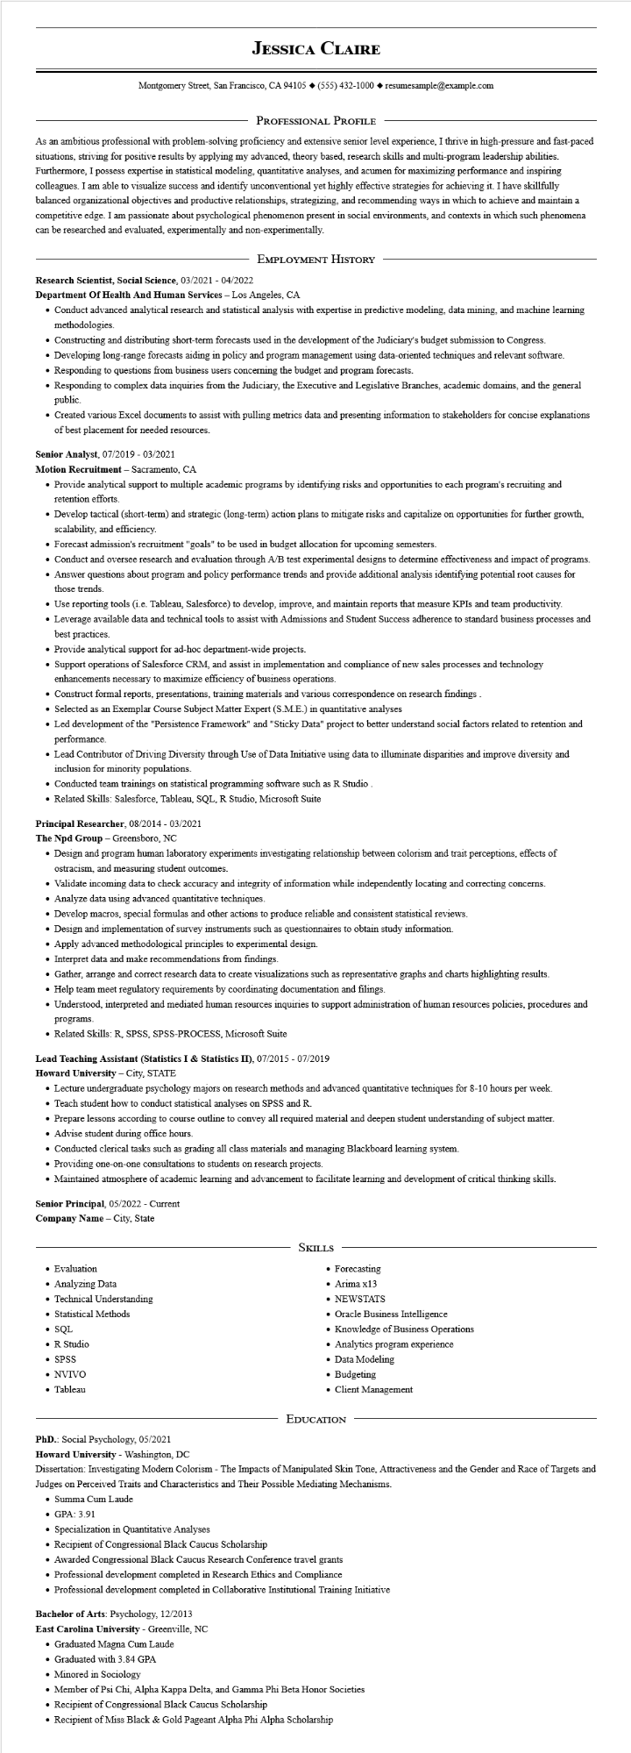
JESSICA CLAIRE
Montgomery Street, San Francisco, CA 94105 ♦ (555) 432-1000 resumesample@example.com
PROFESSIONAL PROFILE
As an ambitious professional with problem-solving proficiency and extensive senior level experience, I thrive in high-pressure and fast-paced situations, striving for positive results by applying my advanced, theory based, research skills and multi-program leadership abilities. Furthermore, I possess expertise in statistical modeling, quantitative analyses, and acumen for maximizing performance and inspiring colleagues. I am able to visualize success and identify unconventional yet highly effective strategies for achieving it. I have skillfully balanced organizational objectives and productive relationships, strategizing, and recommending ways in which to achieve and maintain a competitive edge. I am passionate about psychological phenomenon present in social environments, and contexts in which such phenomena can be researched and evaluated, experimentally and non-experimentally.
Research Scientist, Social Science, 03/2021 - 04/2022
EMPLOYMENT HISTORY
Department Of Health And Human Services - Los Angeles, CA
• Conduct advanced analytical research and statistical analysis with expertise in predictive modeling, data mining, and machine learning methodologies.
• Constructing and distributing short-term forecasts used in the development of the Judiciary's budget submission to Congress.
• Developing long-range forecasts aiding in policy and program management using data-oriented techniques and relevant software.
• Responding to questions from business users concerning the budget and program forecasts.
• Responding to complex data inquiries from the Judiciary, the Executive and Legislative Branches, academic domains, and the general public.
• Created various Excel documents to assist with pulling metrics data and presenting information to stakeholders for concise explanations of best placement for needed resources.
Senior Analyst, 07/2019-03/2021
Motion Recruitment - Sacramento, CA
• Provide analytical support to multiple academic programs by identifying risks and opportunities to each program's recruiting and retention efforts.
Develop tactical (short-term) and strategic (long-term) action plans to mitigate risks and capitalize on opportunities for further growth, scalability, and efficiency.
• Forecast admission's recruitment "goals" to be used in budget allocation for upcoming semesters.
• Conduct and oversee research and evaluation through A/B test experimental designs to determine effectiveness and impact of programs.
• Answer questions about program and policy performance trends and provide additional analysis identifying potential root causes for those trends.
• Use reporting tools (i.e. Tableau, Salesforce) to develop, improve, and maintain reports that measure KPIs and team productivity.
• Leverage available data and technical tools to assist with Admissions and Student Success adherence to standard business processes and best practices.
• Provide analytical support for ad-hoc department-wide projects.
• Support operations of Salesforce CRM, and assist in implementation and compliance of new sales processes and technology enhancements necessary to maximize efficiency of business operations.
• Construct formal reports, presentations, training materials and various correspondence on research findings.
• Selected as an Exemplar Course Subject Matter Expert (S.M.E.) in quantitative analyses
• Led development of the "Persistence Framework" and "Sticky Data" project to better understand social factors related to retention and performance.
• Lead Contributor of Driving Diversity through Use of Data Initiative using data to illuminate disparities and improve diversity and inclusion for minority populations.
• Conducted team trainings on statistical programming software such as R Studio
• Related Skills: Salesforce, Tableau, SQL, R Studio, Microsoft Suite
Principal Researcher, 08/2014 - 03/2021
The Npd Group - Greensboro, NC
• Design and program human laboratory experiments investigating relationship between colorism and trait perceptions, effects of ostracism, and measuring student outcomes.
• Validate incoming data to check accuracy and integrity of information while independently locating and correcting concerns.
• Analyze data using advanced quantitative techniques.
• Develop macros, special formulas and other actions to produce reliable and consistent statistical reviews.
• Design and implementation of survey instruments such as questionnaires to obtain study information.
• Apply advanced methodological principles to experimental design.
• Interpret data and make recommendations from findings.
• Gather, arrange and correct research data to create visualizations such as representative graphs and charts highlighting results.
• Help team meet regulatory requirements by coordinating documentation and filings.
• Understood, interpreted and mediated human resources inquiries to support administration of human resources policies, procedures and programs.
• Related Skills: R, SPSS, SPSS-PROCESS, Microsoft Suite
Lead Teaching Assistant (Statistics I & Statistics II), 07/2015 - 07/2019
Howard University - City, STATE
• Lecture undergraduate psychology majors on research methods and advanced quantitative techniques for 8-10 hours per week.
• Teach student how to conduct statistical analyses on SPSS and R.
• Prepare lessons according to course outline to convey all required material and deepen student understanding of subject matter. • Advise student during office hours.
• Conducted clerical tasks such as grading all class materials and managing Blackboard learning system.
• Providing one-on-one consultations to students on research projects.
• Maintained atmosphere of academic learning and advancement to facilitate learning and development of critical thinking skills.
Senior Principal, 05/2022 - Current
Company Name - City, State
• Evaluation
• Analyzing Data
• Technical Understanding
• Statistical Methods
• SQL
• R Studio
• SPSS
• NVIVO
• Tableau
SKILLS
• Forecasting
• Arima x13
• NEWSTATS
• Oracle Business Intelligence
• Knowledge of Business Operations
• Analytics program experience
• Data Modeling
• Budgeting
• Client Management
PhD.: Social Psychology, 05/2021
EDUCATION
Howard University - Washington, DC
Dissertation: Investigating Modern Colorism - The Impacts of Manipulated Skin Tone, Attractiveness and the Gender and Race of Targets and Judges on Perceived Traits and Characteristics and Their Possible Mediating Mechanisms.
• Summa Cum Laude
• GPA: 3.91
• Specialization in Quantitative Analyses
• Recipient of Congressional Black Caucus Scholarship
Awarded Congressional Black Caucus Research Conference travel grants
• Professional development completed in Research Ethics and Compliance
• Professional development completed in Collaborative Institutional Training Initiative
Bachelor of Arts: Psychology, 12/2013
East Carolina University - Greenville, NC
• Graduated Magna Cum Laude
• Graduated with 3.84 GPA
• Minored in Sociology
• Member of Psi Chi, Alpha Kappa Delta, and Gamma Phi Beta Honor Societies
• Recipient of Congressional Black Caucus Scholarship
• Recipient of Miss Black & Gold Pageant Alpha Phi Alpha Scholarship

